**Project 2 – RH134 – Red Hat System Administration II**

**To connect to the Red Hat Academy classrooms:**

[**https://rha.ole.redhat.com/rha/**](https://rha.ole.redhat.com/rha/)

**Submit a college level report in APA format on the due date. A single word document and PLESE DO NOT ZIP THE FILE.**

**The following needs to be completed for all chapters:**

1. After reading each Chapter proceed to the corresponding Labs in each chapter.
2. The completion of the guided exercises is recommended but not mandatory.
3. Include a report of the execution of all **LAB**s, typically located at the end of the chapters. Before the execution of each Guided Exercise or Lab, please enter this command to set the Linux prompt equal to your first name and last name

**PS1=’ FirstName LastName > ‘**

Note the space the first quote and before the last quote.

Example: **PS1=’ Rolando Fernandez > ‘**

I need to see your name in the prompt to give you full credit. Of course, there may be some labs where you do not use a terminal session and therefore the prompt requirement does not apply in those cases, but you may choose at least one that does. **If you do not meet this requirement, 5 points will be deducted from your grade.**

1. Take a screen picture of the most important screen in the **Guided Exercises** and **LAB**s executions and include it in your report (at least 1, no more than 3 per lab).
2. Take a screen picture where the successful completion message for the labs showing the “finish” script execution and included it in the report.

Each screen picture needs to be inserted into a numerated MS Word figure with **title** and a **note** highlighting your observations of the results shown in the screen picture. **If you do not meet this requirement, 5 points will be deducted from your grade.**

End the Chapter with a Summary of lessons learned section of at least 20 characters. If you do not meet this requirement, 5 points will be deducted from your grade.

1. Once you have used at least 75% of the class, Red Hat will issue a Certificate of attendance for you. **You need to include the certificate at the beginning of your reports. If you do not include your Certificate of Attendance, you will get 5 points subtracted from your grade.**
2. The instructor gets a report of your work in the labs. **If you do not complete the labs in the Red Hat Lab environment assigned for the class you will get zero points for this project.**

Example of the Red Hat Certificate of Attendance:

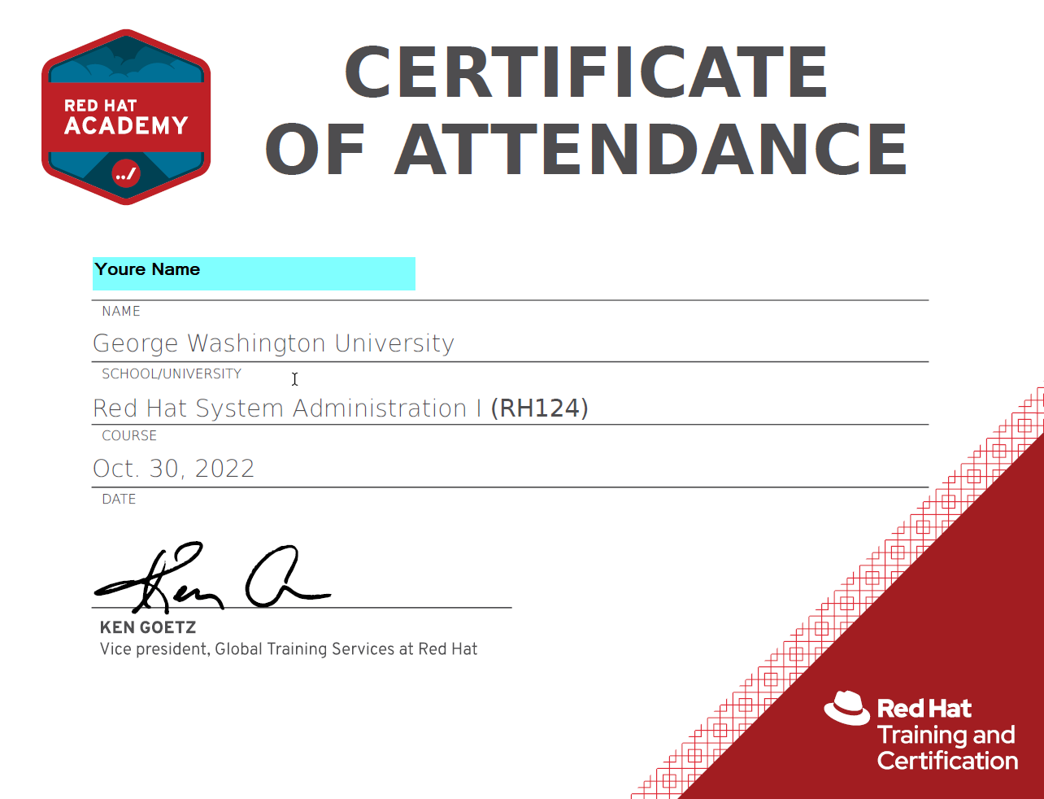

**Appendix A – The Lab Environment**

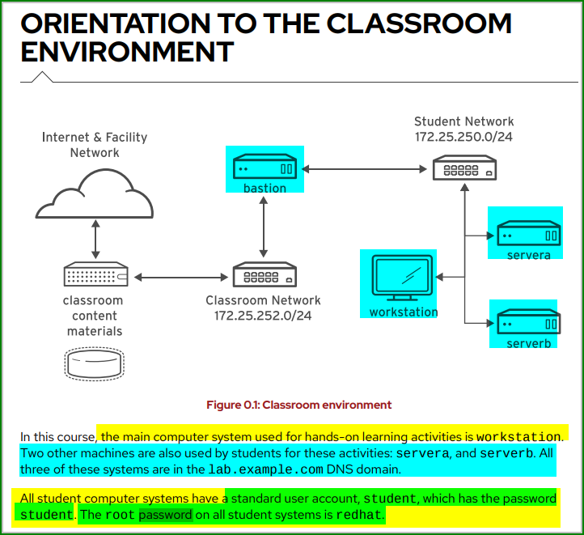

**Appendix B - About the Screen Pictures**

Screen pictures must be inserted in a figure. Follow the following recommendations about the figures:

1. Must be numerated
2. Must have a figure title
3. Must have **Notes** to supplement or clarify information in the image This **Notes** must be at least 20 words. See the example below.

